SPLIT DATASET , TRAINING AND PREDICTION

1. SPLIT DATA SET

Before to use the data set in my model, i split it into train (x_train and y_train) and test (x_test and y_test) sets. This is because the model will use the data in the training set to learn HMM parameters (state initial prob., transition and emission prob.).
Then, i will make a prediction about the data in the test set, using learned parameters.
I can then compare this prediction against the best hidden state sequence (obtained by applying viterbi algorithm on the data in test set) in order to see how accurate the model is.

2. COMPUTE HMM INITIAL PARAMETERS

x_train set : contains list of observation sequence for training
x_test set : contains list of observation sequence for testing
y_train set : contains list of hidden states (same length with x_train)
y_test set : contains list of hidden states (same length with x_test)

I choose two hidden states in y_train set : YES and NO
Let us assume :
- num_yes = occurrence number of state YES in y_train set
- num_no = occurrence number of state NO in y_train set
- num_yes-yes = number of succession from YES to YES in y_train set
- num_yes-no = number of succession from YES to NO in y_train set
- num_no-no = number of succession from NO to NO in y_train set
- num_no-yes = number of succession from NO to YES in y_train set
- num_yes-obs_i = number of observation ‘i’ being in state YES in train sets
- num_no-obs_i = number of observation ‘i’ being in state NO in train sets

State initial probabilities :
- pi[YES] = num_yes / (num_yes + num_no)
- pi[NO] = num_no / (num_yes + num_no)

State transitions probabilities :
- A[YES][YES] = num_yes-yes / (num_yes-yes + num_yes-no)
- A[YES][NO] = num_yes-no / (num_yes-yes + num_yes-no)
- A[NO][NO] = num_no-no / (num_no-no + num_no-yes)
- A[NO][YES] = num_no-yes / (num_no-no + num_no-yes)

State emissions probabilities :
- B[YES][obs_i] = num_yes-obs_i / (num_yes-obs_i + num_yes-obs_j)
- B[YES][obs_j] = num_yes-obs_j / (num_yes-obs_i + num_yes-obs_j)
- B[NO][obs_i] = num_no-obs_i / (num_no-obs_i + num_no-obs_j)
- B[NO][obs_j] = num_no-obs_j / (num_no-obs_i + num_no-obs_j)

3. TRAIN HMM

See «Report n.3»

4. PREDICTION

Given a sequence of observation ‘V’, what will be the probability that the HMM will be in a particular hidden state ‘s’ at a particular time step ‘t’.

I use ‘Trellis diagram’ to get the intuition behind the Forward algorithm.
Trellis diagram allows us to compute ‘beta matrix’ (Forward probabilities), that contains the probability to be at a particular hidden state ‘s’ at time step ‘t’, after emitting first ‘t’ observation sequence (subset of V) :
α_{j} (t) = π_{j} b_{jk} when t=1
α_{j} (t) = b_{jk} ∑^{len(states)} α_{i} (t-1) a_{ij} when t>1
i=1
Here α_{j} (t) is the probability that the model will be at hidden state ‘s_{j}’ at time step ‘t’, after the observation ‘obs_{t}’ at the time step ‘t’.

For example, refer the below Trellis diagram and assume the probability that the model is at hidden state ‘s₁’ at time (t−1) is α₁(t−1). The probability of transition to hidden state ‘s₂’ at time step ‘t’ can be now written as α₁(t−1)*a₁₂

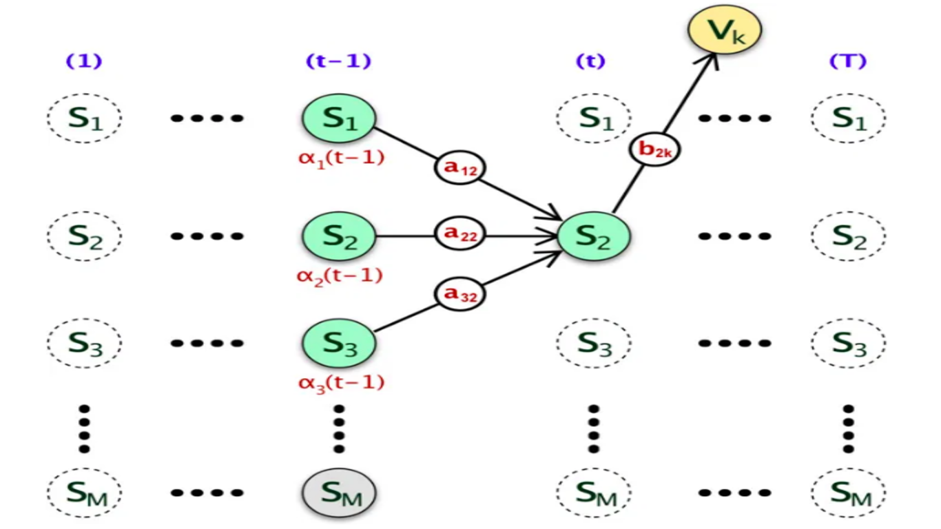

Then, the model will be at the time step ‘t’ at the hidden state with the higher probability in time step ‘t’.

